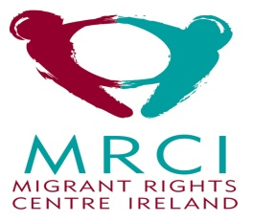
QQI HEALTH CARE SUPPORT COURSE funded by MRCI
Application Form

Please complete the application form below and submit to linda@mrci.ie by Sunday 15th March.

Personal details

Name:

Surname:

E-mail:

Contact number:

Address:

Postcode:

City:

Country of birth:

Nationality:

What is your current immigration status?

What is your current occupation?

1. Why are you interested in doing this course?
(100 words max)

2. Do you have any experience working as a carer?
(100 words max)

3. What issues do you think migrant carers face in the workplace?
(100 words max)

4. In a few words tell us what it means to be a good carer?
(100 words max)

5. What do you expect to gain from this course?
(100 words max)
6. Do you have any special requirements?

This project Is suported by MRCI, the Department of Justice and Equality and the European social Fund.

