55 Parnell Square west, Dublin 1
2012
Migrant Rights Centre Ireland
“Working for justice, empowerment and equality for migrant workers”
Annual Report
Introduction and context
This report covers the period 2012 and provides a comprehensive overview of progress made towards achieving our stated objectives set out in MRCI’s Strategic Plan 2012-2014.
The overall agreed outcomes identified in our strategic plan remain achievable, albeit over a longer period of time for some. The recession is having a negative impact on the lives of migrants and this is generating a higher demand for support especially in areas such as undocumented workers rights. The number of forced labour including trafficking cases we are managing doubled in 2012. Combined with the impact of austerity MRCI has been forced to implement imitations in relation to services and supports. In addition the policy environment has become increasingly difficult and pressured. The legislative process has become increasingly delayed with a growing backlog of legislation and policy decisions.
On the other hand opportunities for advancing important issues and policy priorities continue to exist for example there is a noticeable interest at senior level in some of the major government departments on issues of inclusion and integration.
The initial view that recession would result in many migrants departing has given way to recognition that the diversity of society is deepening and our demographic profile will continue to reflect a multi-cultural and diverse population.

MRCI Strategic Aims & Priority Objectives
MRCI’s strategic aims for the period 2012 – 2014 seek to advance equality and rights in four dimensions
Resources: To advance economic justice and rights for migrants at risk of poverty, social exclusion and exploitation
Income adequacy, freedom from exploitation, access to and progression within the labour market have a direct bearing on lives and status of all members of society. Migrants with an insecure legal status and working in poorly regulated sectors are at particular risk of experiencing human rights abuses and injustice.

Analysis of the MRCI Case Work
The data presented here relates to the period January to December 2012. The presenting issues were varied and include; (starting with the most frequent) Undocumented, Work Permit, Employment issues, Change of Legal status, Citizenship, EU and Irish spouse dependents, Family Reunification, Social Welfare, Non EEA Spouse dependents, Independent Status, Racist Incidents, Education Fees and Education Access, Health Service Access, Income Adequacy, Maternity Health, Mental Health.
MRCI provided information, referral and advocacy including outreach work to 2,650 migrants in 2012, and this is a (documented) increase of 33% on 2011 figures. Migrants came into contact with MRCI in 2012 primarily through the Resource Centre (88.3%).
Migrants contacting MRCI came from over 100 different countries around the world with the largest number coming from countries outside the European Union. The top five countries from which migrants contacted the MRCI was Philippines (12.6%). This was followed by China (11.7%), Mauritius (9.1%), Pakistan (7.9%), and Bangladesh (4.9%)
In 2012 there was a greater number of males, 57.4% contacting MRCI. Female migrants made up 41.4%.
The employment status/job sector of individuals receiving information and referrals were as follows, not in employment (25.6%), other (17.6%) restaurant and catering (15.3%), shop and retail (6.8%), care work (4.9%), cleaning and maintenance(4.8%),domestic work (private home) (3.6%), hotel and catering (3.5%), security services (2.8%).
The trends of presenting immigration status issues are very similar to previous years. The presenting issues were as follows; undocumented (27.6%), stamp 2 (22.0%), stamp 4 (16.5%), EU citizen (13.5%), stamp 1 (6.4%), stamp 3 (3.6%), Irish citizen (1.9%), asylum seeker (1.4%).

Criminalisation of Forced Labour
MRCI has been recognised as a leading NGO in responding to forced labour at a national and international level. We have been invited to present to several international meetings and conferences in the past year. In association with the Irish Labour Inspectorate and the Anti-Human Trafficking Unit we have been cited as having developed good practice. This has stemmed from the joint training/projects we have developed with state agencies in responding to the needs of victims of forced labour.
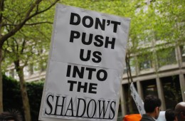
Following intense campaigning it is anticipated that the Minister for Justice will publish legislation that will criminalise forced labour in 2013. A critical area of concern for MRCI is the level and range of protections and supports to be provided for victims of forced labour
MRCI has also commenced two small scale projects in conjunction with Anti-Slavery International on a) mapping criminalisation of potential victims of forced labour for drugs trafficking offences and b) training and capacity building with trade unions and labour inspectorate on trafficking 2013
During 2012 forced labour was addressed by a number of important current affairs and news programmes including a RTE Primetime report.
Low paid and decent work for migrant worker
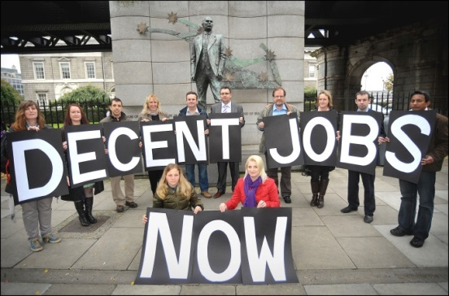
The focus of MRCI’s work this year has been to generate discussion and dialogue on the concept of Decent Work and to build stronger collaboration and partnerships with trade unions on advocating for decent work. A successful Round Table was held in October in conjunction with SIPTU and the Coalition to Protect the Low Paid, where former ILO expert, Patrick Taran presented global migration trends. The ‘London Citizen’ project a highly successful civil society initiative was presented as a potential model for collaboration by Kevin Curran of UNITE UK. A highlight of 2012 was the production and launch of a short film ‘Food for Thought’ which addressed ethical food concerns from perspective of workers in food industry and involved employers supportive of decent work conditions for employees. http://vimeo.com/migrantrightscentre/food
Decent Work is a growing global agenda and MRCI will frame many of its concerns re employment rights and conditions for migrant workers within this frame. SIPTU, the largest trade union in Ireland has established a migrant worker committee and is developing a programme of action to ensure that migrant workers concerns are addressed in a more strategic and meaningful way. We are supporting this process and contributing to an institutional approach to migrant worker equality within SIPTU.

Rights of Work Permit holders
A core concern for MRCI has been the on-going difficulties being experienced by work permit holders arising from lack of coordination and policy synergy between the respective departments responsible, the INIS (Department of Justice) and Work Permit Section (Department of Employment and Jobs). This lack of coordination results in on-going difficulties for people applying for permits who have been given temporary residency stamps. Following on-going discussion and advocacy with both departments an improved processing system has been agreed which will lead to improved outcomes for work permit applicants.
2012 saw the conclusion of the High Court case initiated as result of the Labour Court awarding Muhommad Younis, an exploited chef unpaid wages. The High Court determined that the Labour Court could not make such an award because workers without a ‘legal contract’ have no right to access legal redress under current employment law. This decision received significant national coverage because of its impact but also because the decision was referred to the government and Minister Bruton. The current status quo i.e. no access to legal redress impacts greatly on those who held work permits but who are now undocumented and many case MRCI currently supports are no longer able to proceed. Minister Bruton met with MRCI and Muhommad Younis to discuss the situation and committed to resolving it as soon as possible. MRCI was asked to make a substantial submission in anticipation that the current Work Permit legislation will be reformed.
Representation that migrants are empowered to be active participants in decisions that affect their lives
The right to participate in decisions impacting on your life is an important element in building an effective democracy. Migrants in vulnerable situations are generally denied access to the political and decision making structures governing society resulting in uneven and poorly developed policies and decisions.
Participation and representation of migrant workers
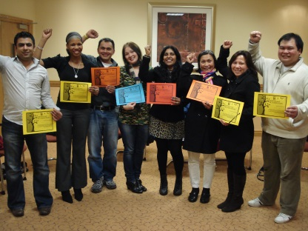
The participation of migrants is at the heart of MRCI’s approach to social change. A ‘Leadership Framework’ that supports the engagement of new potential leaders through to identifying progression routes for existing leaders was developed in 2012 .
MRCI’s communications infrastructure was updated to enable the smooth and active participation of individuals into the collective work of MRCI i.e. Action Groups and Campaigns. This includes streamlining individual contacts with campaign work and ensuring that the process of on-going relationship development is a core part of our communication strategy.
In 2012 MRCI’s website was redesigned and now represents our emphasis on engagement and mobilisation. http://www.mrci.ie/. We have held a number of training sessions on the role of communications in mobilisation and campaign work. Core parts of our on-going work in this area are workshops on public speaking, communications, power analysis, strategy development and campaigning. All campaigns have an action group in place made up of people directly impacted by the campaign issue. Regular induction and development meetings are held.
Migrants Forum
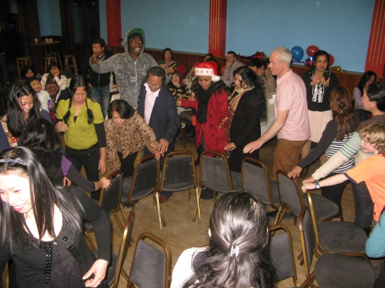
The Migrants Forum is held every quarter in the Teachers Club on Parnell Square. The Forum provides an opportunity for migrant workers to receive and share information, form a collective analysis of their experiences, and take action on issues affecting their lives. The Forum continues to be an important opportunity to foster self-advocacy and to support the leadership potential of migrant workers. The issues focused on during 2012 were access to third level education for children of non-EU immigrants, the recession and a discussion on making Dublin home. UN International Migrants Day was celebrated on December 16th and was another great success.
Community and local development supports
During 2012 there were two practice seminars organised in conjunction with the Community Workers Cooperative. The practice seminars provided participants an opportunity to develop an analysis of the critical issues facing migrants in Ireland today with a particular focus on current challenges such as racism, poverty and the increasingly precarious working conditions facing migrants in low paid work. They also provided a space to explore the opportunities a community work response can bring in reaching the most vulnerable and building real and meaningful participation.

Recognition: To challenge institutional discrimination and racism
Reflecting the diversity of the population in the policies, structures and practices of institutions is core to realising equality and rights for all. Irish institutions have been slow to realise that migration and immigrants in society is a permanent reality. This results in poorly planned policies and discriminatory institutional practices.
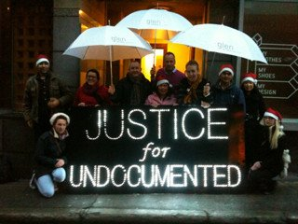
Justice for the Undocumented Campaign
2012 saw the acceleration of the Justice for Undocumented Groups campaign for the introduction of an earned regularisation scheme.
The Labour Party passed a motion in support of earned regularisation in April 2012 and three local councils have now supported earned regularisation for all those who are undocumented and who have made Ireland their home. Engagement with politicians on a cross party basis to build support and championing for the proposal has been a priority focus in 2012. Dialogue with Department. of Justice is on-going with increasing focus on areas of possible contention if earned regularisation to be introduced.
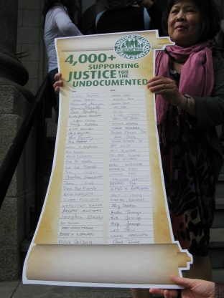
In December 2012 the Justice for Undocumented Group made a presentation to the Oireachtas Committee on Justice who have now committed to engaging Minister Shatter in a dialogue on earned regularisation.
A Private Members Bill is currently being drafted for introduction to the Dáil in 2013 and efforts to build cross party support continue.
A number of pubic actions were conducted in 2012 including 3,000 petitions presented to the Dept. of Justice officials and the formation of a ‘Human Shamrock ‘St Patrick’s Day with over 200 undocumented migrants participating http://www.mrci.ie/our-work/justice-for-undocumented/
An outreach strategy is in place and meetings held in a range of locations throughout Ireland. Group membership now stands at over 250. Regular meetings and engagement with undocumented migrants and training of leaders continues to be conducted.
During 2012 a Student regularisation scheme was introduced. MRCI has actively supported the campaign for a solution to the situation of ‘timed out’ students and some of its features resemble MRCI proposals made to the Department of Justice. The approach that seems to be gaining momentum is to target categories of migrants for regularisation/special decisions.
MRCI continues to play an active role on the Board of PICUM the international organisation working for the rights of undocumented migrants.
Young People & Education
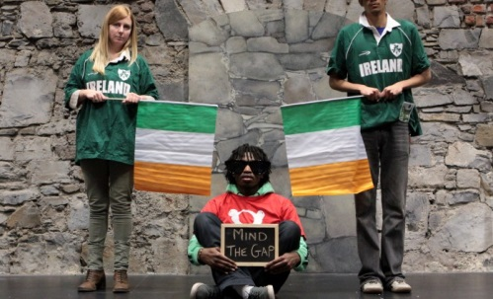
Thousands of children of non-EU migrants who have made Ireland home face significant barriers in accessing third level education, in the form of excessively high tuition fees arising from the fact that they do not yet have citizenship. These are young people who, in the main, joined their parents under family reunification and are living here for a minimum of 3 years. Many of them have completed their primary and secondary level education in this country, but cannot advance to third level with their friends and classmates. In response to this growing problem facing migrant families, MRCI formed the Migrant Education Access Campaign Group in April 2012. MEA is made up of concerned parents and young people, who along with allies and supporters, are campaigning for equality of access to third level education for children of non EU migrants. MEA has achieved a lot in a short period, outreaching to hundreds of migrant families, raising awareness of the problem in national media and supporting leaders to emerge through its leaders group which meets regularly to plan and advance actions.
In December 2012, a presentation was given by young people and MRCI to the Oireachtas Joint Committee on Social Protection and Education alongside the Irish University Association and the Institutes of Technology Ireland.
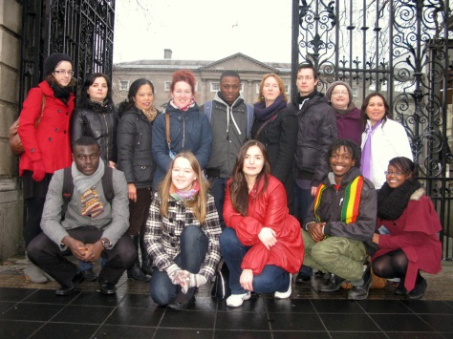

Racism and ethnic profiling
The priority concern this year has been to support the Irish Network Against Racism especially its work in the area of racist incident recording and monitoring. Organisations nationally and locally and ranging from Traveller rights to asylum seekers rights to migrant and immigrant issues are collaborating on this vital area. A revamped reporting system is being worked on and there will be increased public focus on this issue in 2013. Funding from the Community Foundation of Ireland will provide a solid foundation for the Network to develop and grow.
In relation to ethnic profiling a strategic legal case is due to be presented to the High Court and will address specifically the role of Guards in relation to ‘stop and search’ practice

Respect: To progress human rights of migrants as providers of care
Care, how it is organised and who provides it is a burning issue in all developed societies. Emerging trends indicate that migrant workers, mainly women will constitute the majority of care workers into the future.
Domestic Workers Action Group (DWAG)
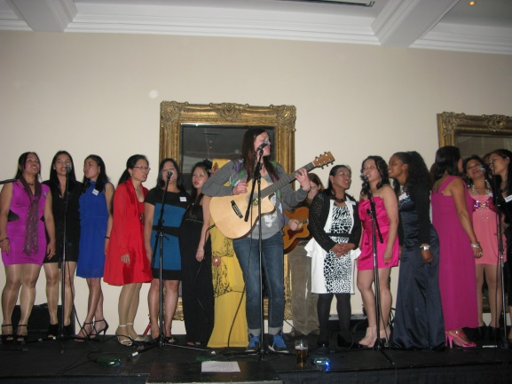
2012 was another busy year for DWAG , There were 12 core group meetings and 6 wider network meetings held during the year. DWAG leaders met with UN Women representative Jean Ggunca in November and the group was recognised as ‘best practice’ model in empowering domestic workers. In September there was a residential leadership development weekend held with twenty of DWAG’s leaders. In November DWAG’s annaul general meeting and fundraiserier was another great success. 210 members and strategic allies attended including President of SIPTU, Jack O’ Connor.
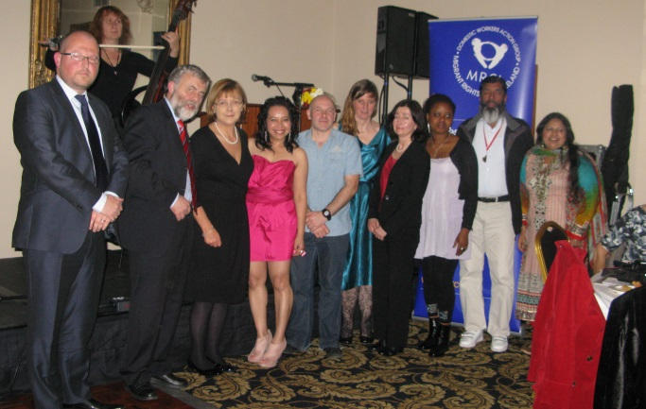

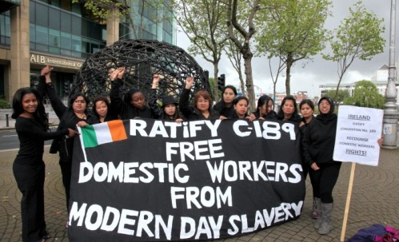
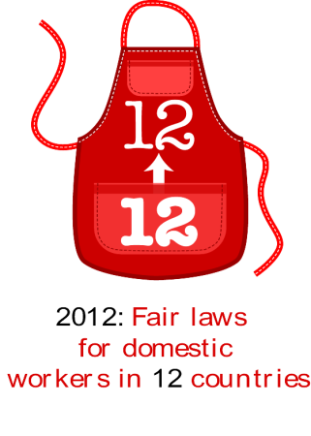
DWAG actively campaigns for rights for domestic workers both nationally and internationally, collaborating with trade unions and international domestic workers networks. In 2012 members travelled to the International Labour Organisation to participate in discussions leading to the adoption of the International Labour Organisation (ILO) Convention C.189 on Decent Work for Domestic Workers. On June 16, marking the first anniversary of the convention, DWAG joined the ITUC global campaign ‘12 by 12’ calling for governments to ratify C189, and urged Minister Bruton to take action by bringing Irish laws in line with the international convention.
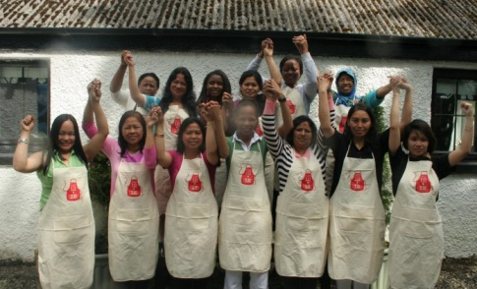

‘One Voice’ Launch
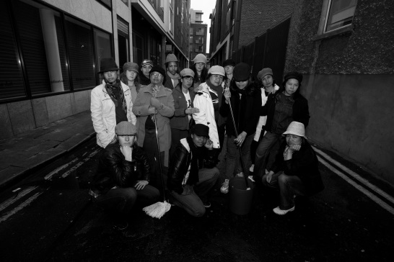
In May, music collaboration between musicians, activists and migrant domestic workers was launched with the song ‘One Voice@’. The musical collaboration was a twelve week project using music for political awareness raising and as a way to share the experiences of migrant women living and working in private homes in Ireland. ‘The Soul Workers Session’ was a night of reggae, folk, hip hop and spoken word with migrant domestic workers and musicians to raise awareness about the exploitation that many migrant women experience in Ireland as domestic workers.

Migrant Care Workers
An initial scoping study on the experiences of migrant women was conducted (120 migrant care workers) and a Roundtable held in Nov 2012. http://www.mrci.ie/press-centre/new-study-reveals-40-of-migrant-care-workers-feel-discriminated-against/
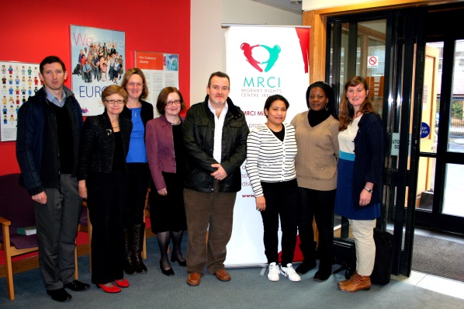
The Equality Authority has actively supported this work and a meeting with the Human Rights Commission has resulted in an increased recognition of care as a human rights and equality priority. The Labour Inspectorate has agreed to engage with HIQUA to develop a plan for inspections for home care settings. Aging and disability rights organisations are also interested in joint approaches to improving protection of care users and workers.
A feasibility study on a social economy model of care provision in the private home has been initiated and this is an area that will be developed in the coming year.

Au Pairs
Au pairing in Ireland is a thriving industry. Despite the growing numbers of families using au pairs, accurate data on au pairing is extremely limited and little is understood or documented about the experiences of au pairs. MRCI conducted a small scale research project detailing the experiences of au pairs. The findings of an MRCI report point to the systemic abuse of the concept of au pairing. It seems evident that au pairs are being used as a cheap form of childcare, which also highlights the lack of regulation of the industry. http://www.mrci.ie/wp-content/uploads/2012/12/Part-of-The-Family.pdf. There has been a high level of interest in this issue and it is likely to be an area of attention into the future.
Communications
Understanding our core sustainability needs has also been an area of focus. In light of this we have been in a process of revamping our communications and internal data management systems to enable more efficient work methods.
MRCI continued to maintain and strengthen its political profile during 2012. The various campaigns we were involved in provided opportunities for extensive coverage i.e. Primetime, national and local news – print and broadcast. Media coverage in 2012 continued to be high, with regular press coverage of MRCI campaigns. There were 53 articles in national press including fourteen articles in the Irish Times covering the issue of Regularisation of undocumented workers, Access to third level education for the children of immigrants, Forced Labour and Au pairs. Radio coverage included several news items as well as more in-depth discussions e.g. Today FM – Last Word where the issue of Domestic Workers was discussed and a feature on the Pat Kenny show (forced labour and domestic workers exploitation). Television coverage (15 hits) including a Primetime piece on Forced Labour. MRCI’s social media presence also increased with a significant number of ‘likes’ on Facebook being people from migrant communities.

Organisational Development
We commenced our new strategic plan for the period 2012 – 2014. MRCI’s long term vision is that of a society where migrants have their rights fully realised and have access to justice in a society that supports and enables equality for all. The visibility and participation of migrants in that process is vital and through our work we actively support and enable migrants to be leaders in advocating for an equal society.
As a reflective and learning organisation regular opportunities are created for developing our collective analysis on relevant issues, reflecting on our work and generating new ideas and ways of advancing our vision.
Special thanks is offered to the interns, volunteers and students from NUI Maynooth who contributed so much to the work of MRCI during 2012 including Sarah-Jane O’Connor, Emma King, Mishael Najm, Dee Keogh, Grace Kennedy, Caroline Reid, Maeve Glavey, Yvonne O’Sullivan, Ian McGahon, Evelyn Regan, Fionn Fitzpatrick, Dubhaltach Mulvenna, Daniel Kearney, Miranda Ruddock
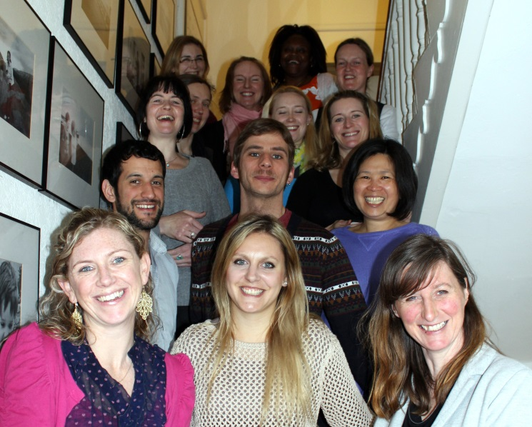

MRCI Team 2012

Funding
The funding environment continues to be challenging and we are ensuring that we not only survive but operate more effectively by strengthening our board and realigning funding strategies in line with new economic realities. We continue to receive support from the Columban Missionary Society. In June we received a commitment from Atlantic Philanthropies to continue to fund our work over the next 30 months. In April we received funding from the Anti-human Trafficking Unit in Department of Justice which funds some of our forced labour work. In August we received a grant from the Community Foundation of Ireland to support our Migrant access to third level education campaign.
A vigorous approach to identifying alternative sources of finance is being taken. This includes a focus on European and international funding sources, identification of potential partners and suitable project areas that complement our core objectives. A second strand is the engagement of trade unions in a process of joint agenda building and exploration of innovative approaches to securing shared goals.
The Board has established a working group to oversee the sustainability plan for MRCI and it is expected in 2013 key decisions will be made about our future structure and operating requirements.
Substantial time and resources was dedicated to the ‘For Impact’ Funding model. Unfortunately despite commitments made the anticipated return was not realized.

Governance
MRCI’s Board met 5 times during 2012. The Finance Subgroup met 4 times and the Staff and Employment Subgroup met 2 times. The annual joint team/Board meeting took place in December where the work programme and budget for 2013 was presented, discussed and agreed. Another joint meeting was held in October to discuss MRCI’s future sustainability and direction. There were two resignations from the board in 2012; Julius Fokasi and Meena Baskarasubramanian. New appointments were Amel Yacef, Bill Abom and Lucy Peprah.

Risk Analysis
Sustainability is a burning issue for MRCI. Core funding has been received from two philanthropic foundations since 2005. Both ONE Foundation and Atlantic Philanthropies has provided 70% of MRCI’s funding. The One Foundation funding is coming to an end in 2013. Atlantic Philanthropies current funding stream will be ending at the end 2014. The reality is there are not many opportunities in Ireland for funding. Due to the lack of funding opportunities MRCI continued in 2012 to reduce costs as much as possible, we managed to reduce our cost base by 25% compared to 2011.
Meeting the funding needs of the organisation presents the biggest risk to the work of MRCI, but we are working hard to access as much potential funding as possible. In 2014 the EU Asylum and Migration Fund (ATM) is due to become operational in Ireland. At the end of 2012 MRCI in conjunction with a number of migrant organisations met to begin the process of lobbying the government to create a bridge fund as there is likely to be a significant time delay between the completion of the current EIF and ERF funds and the commencement of the AMF. As a result urgent steps are needed to make available a bridging fund on the basis of clear criteria to ensure coherence between the two funding streams to enhance long-term sustainable actions. This fund merges the European Refugee Fund (ERF), the European Fund for the Integration of third-country nationals (EIF) and the European Return Fund. This may be the only fund available for migrant organisations in the next few years so will be crucial to ensure the integration and social inclusion of immigrants and their families in Ireland.
At every board meeting in 2012 the future of MRCI was on the agenda. The continuing sustainability of MRCI is of major concern and being regularly addressed with different options being discussed.
Ultimately it is MRCI’s goal to ensure migrants have full equality and are free from discrimination and injustice. Rather than solely focusing on the existing structure of the organisation, MRCI is open to evolving as an organisation and is responsive to new means of achieving this goal.

