2011

Working to promote Justice, Empowerment and Equality for migrant workers and their families

Migrant Rights Centre Ireland Annual Report

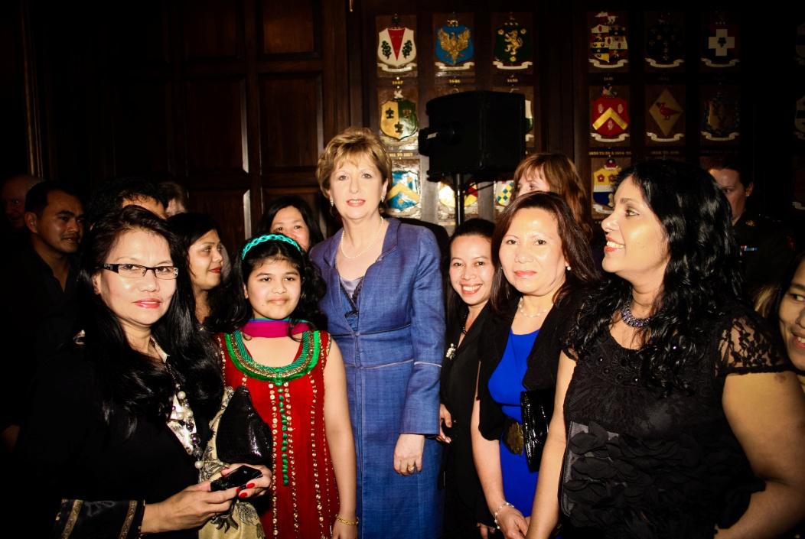

Introduction and context
This annual report covers the final year of our three year strategic plan (2008 – 2011). 2011 was also the ten year anniversary of MRCI. During 2011 we undertook a review and reflection process. This process was to enable MRCI’s stakeholders to identify the various options for its work in the future and support our strategic planning process which was also completed at the end of 2011.
The funding and policy environment continued to be a challenging one throughout 2011 but despite this MRCI continued its work to advocate for the rights of migrant workers while also advocating for a more just and equal society. This year was very productive with the achievement and progression of a number of organisational goals as set out below.
Within this context MRCI continues to advocate for the rights of migrant workers while also advocating for a more just and equal society. This year was very productive with the achievement and progression of a number of organisational goals as set out below.

Strategic Objective: to strengthen the rights and protections for migrant workers who are at risk of or experiencing workplace exploitation, are trafficked for forced labour or are undocumented
Workplace Exploitation
Formal protections for employees at risk of exploitation/discrimination identified across sectors and categories of migrant workers agreed.
Migrant workers experiencing less exploitation and discrimination in the workplace.
During 2011 we continued to provide information and advice through our outreach services. These were themed information supports comprising of workshops and clinics on specific themes relating to rights and entitlements. Some of the key issues experienced by migrant workers and their families which we addressed; Work permits, Citizenship, Workplace Rights, Family Reunification, Trafficking for Forced Labour, Access to third level education and the ECJ ruling for some parents of Irish born children having the right to reside in Ireland also known as the Zambrano Case.
We continued to support migrant workers with the information needed to self manage and this will be an ongoing priority in light of reduced resources.
MRCI continued in 2011 to work with the National Employment Rights Authority (NERA) in improving protections for migrant workers. There is ongoing collaboration on individual cases, work sectors and emerging issues. To date, nineteen employers covering nineteen employees in the domestic work sector have been inspected by NERA.
Justice for the Undocumented Campaign
Based on data from the Department of Justice, Equality and Law Reform (DJELR), there are approximately 30,000 undocumented people in Ireland today. Undocumented migrants, including children, are at greater risk of exploitation, poverty and social exclusion, and often live in situations of destitution. MRCI has advocated for the rights of undocumented people since 2001. Many are working, paying taxes and trying to support themselves and their families. Throughout 2011, a core group of undocumented migrants led the “Justice for the Undocumented Campaign’. There were meetings with high level officials, county council motions and visits to TDs. A proposal has been put forward to the Minister of Justice for an Earned Regularisation scheme. Earned regularisation refers to the process of allowing undocumented migrants to come forward and ‘earn’ temporary and/or permanent residency rights by fulfilling various criteria over a specified time period. There are now over 200 members of the wider campaign group.
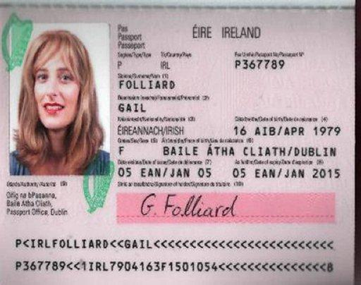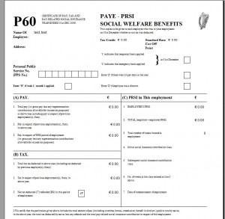
2. Probationary Immigration Status
3. Earning credits:
2-5 years
4a. Permanent Residency Granted

4b. Unsuccessful application

REPATRIATION
Work & paying taxes
Community involvement
Family integration
1. Register and pay fine

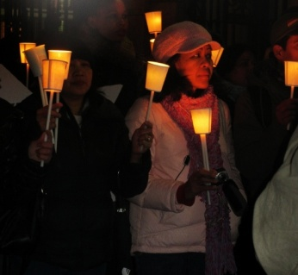
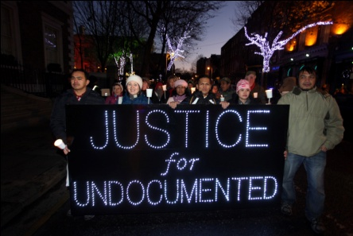
On December 17th, over a hundred undocumented migrants, their families and supporters marched by candlelight to Dáil Éireann on the eve of UN International Migrants Day to highlight the plight of the 30,000 undocumented migrants living in Ireland. The march was organised to call on the Irish Government and Minister for Justice, Alan Shatter, TD, to introduce an Earned Regularisation Scheme.

Forced Labour
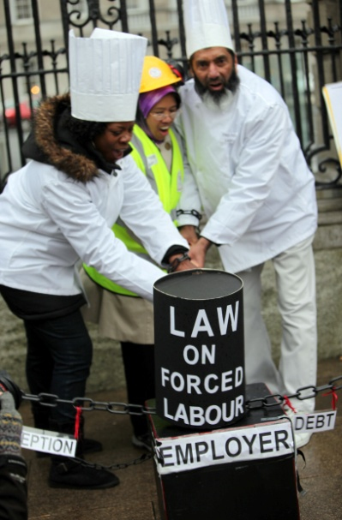
Throughout 2011 we continued to work with victims of forced labour. The problem of securing ‘recovery and reflection’ period for potential victims is still a concern, but the mainstreaming of support from external sources continues to improve.
The legal opinion commissioned by MRCI in relation to the interpretation of forced labour as a crime under current legislation was referred to the Attorney General. The Attorney General requested An Garda Siochanna to prepare an analysis of cases to date on forced labour which would identify any gaps in the law to investigating and bringing prosecutions of forced labour. At the end of 2011 this report was still with the Minister for Justice who will make a decision as to what is required to deal with the problem of forced labour.
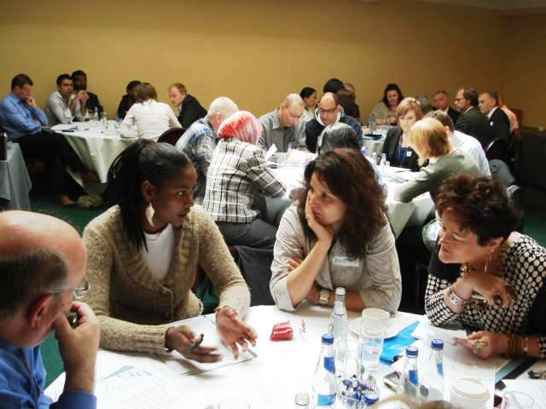
In June a high level seminar was held with officials, international experts and other stakeholders including An Garda Siochanna. The Forced Labour Action group whose members are people with an experience of forced labour met on a monthly basis and participated in numerous training and media actions. In December members of the Forced Labour group held an action outside the Dáil to mark international day for the abolition of slavery and to call on the government to criminalise forced labour which is a form of modern day slavery.
Diplomatic Immunity and Domestic Workers
During 2011, MRCI continued to focus on campaigning for greater justice for domestic workers employed by diplomatic staff. MRCI has requested a meeting with Minister for State Jan O ‘Sullivan to discuss policy development on the issue of protections for domestic workers employed by diplomats. In November 2011 MRCI received confirmation from the Department of Foreign Affairs that a draft paper responding to this issue is in progress. There have been ongoing meetings between MRCI and the Protocol Section of the Department on the issue.
The Right to Change Employer Campaign
The right to change employer without having to secure a new work permit remained a critical issue in the advancement of rights for migrant workers. Throughout 2011 work continued on this issue, meetings were held with the Dept of Enterprise, Trade Employment including the then Minister for Labour Affairs. Despite a recommendation from the Oireachtas on Employment that a resolution be agreed no progress was made primarily as a result of the economic crisis and subsequent change of government.
Protecting the Minimum Wage
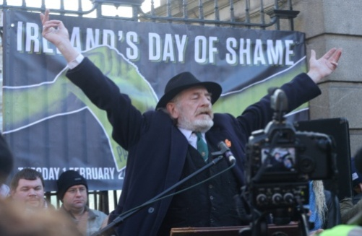
On February 1st 2011, the cut to the National Minimum Wage came into effect. A significant number of people on minimum wage are migrant workers. MRCI worked closely with the trade union movement to respond. In February a “Day of Shame” was held outside the Dáil. This was organised in collaboration with a coalition of trade unions and community sector organisations. All the names of the TDs who voted in favour of the cut were called out and pledge cards were signed by politicians asking them to commit to reverse the cut to the minimum wage and to protect Employment Regulation Orders. When the new government came into power in March the minimum wage was restored to the original level.
Strategic Objective: To mainstream a focus on migrant workers at risk of social exclusion, poverty and discrimination within service and information provision and within community and local development
Case and legal advocacy work
In line with our strategic plan case and legal advocacy work this area of work became more targeted and strategic during 2011, honing in on particular campaigns we were undertaking. This was necessary to ensure our ability to maintain standards, respond to those in greatest need, and ensure our case work operates in line with our strategic priorities.

Analysis of the MRCI Case Work
The data presented here relates to the period January to December 2011 and is quantitative. The presenting issues were varied and included; citizenship, work permit queries, undocumented worker issues, workplace rights issues, social welfare and protection, family reunification and racist incidents. MRCI provided information, referral and advocacy to 1,678 migrants in 2011.
Migrants came into contact with MRCI in 2011 via a number of intermediaries, but were primarily recommended to MRCI by members of their own communities. 70.8% heard about the organisation through word of mouth. Organisations such as CIC, SIPTU, ICI, etc referred 9.2% of people to MRCI. 2.3% contacted us through our website with the rest arrived through various other avenues.

Migrants contacting MRCI come from over 100 different countries around the world with the largest number coming from countries outside the European Union. The top five countries from which migrants contacted the MRCI was Philippines (14.5%). This was followed by China (7.6%), Romania (7.0%), Pakistan (6.7%), and Mauritius (5.7%)
In 2011 there was a greater number of male (59.1%) versus female migrants (40.9%) contacting the organisation. The average age of people using MRCI’s services was 40 years old and the average year of arrival in Ireland was 2001.

The employment status/job sector of individuals receiving information and referrals are as follows, not in employment (37.4%), restaurant and catering (13.2%), other (10.9%), shop and retail (7.7%), cleaning and maintenance(5.1%),domestic work (4.1%), medical and healthcare (3.8%), agriculture (1.9%).construction (1.6%), and manufacturing (1.1%).
The trends of presenting issues are very similar to previous years. The presenting issues were as follows; work permit (20.8%), undocumented (20.5%), citizenship/residency (17.8%), workplace rights (15%), social welfare/protection (3.3%), family reunion (1.9%), racist incident (0.3%) and other (20.4%).
There were 763 referrals made in 2011. The majority of people were referred internally to Irregular Migration (29.7%), Migrants Forum (22.8%) Workplace Rights (18.8%), Restaurant Workers Action Group (3.8%) and Domestic Workers Action Group (2%). There were external referrals made to Government bodies (7.3%), and Other NGO’s (13.1%).
Irregular Migration
In 2011, the Migrant Rights Centre Ireland assisted 227 migrants with an undocumented status. (23.1%) of these had arrived in Ireland on a tourist visa, 29% arrived on a student visa, (21.5%) were on stamp 1/work permit. The top five nationalities were Philippines (20.8%)m China (11.5%), Brazil (7.7%), Bangladesh (6.2%) and Mauritius (6.2%). 15.4% had been in Ireland since 2006, 12.3% has been here since 2007 and 10.8% had been here since 2002. Again word of mouth was the most common way people were referred to us at (70.8%). The reasons for becoming undocumented were varied and included; (26.9%) had overstayed their visa, (10%) had been made redundant, and (6.9%) had their work permit refused.
The top five nationalities of persons accessing the services of the Irregular Migration team. which represents 73% of the workload of the Project Team are as follows; Philippines (13%), China (10%), Ukraine (9%), Moldova (6%) and Pakistan (5%). 65% are male and 35% are female. The principal job sectors were; restaurant and catering (15%), domestic work (5%), cleaning and maintenance (4%), construction (4%) and agriculture (2%).
There was an increased focus from the Irregular Migration Team to meet and work with undocumented migrants who currently have no avenues to rectify their legal status. This is as part of the build-up to the Justice for the Undocumented campaign. As part of the work, a focus is put on guaranteeing the access to fundamental rights (healthcare, education, housing, employment rights and social welfare rights) for undocumented migrants and their families.

Workplace Rights
In 2011 the Workplace Rights team were referred 273 people by the Drop in Centre. In line with MRCI’S new policy of only taking on strategic cases, most of them were referred to our legal panel or were encouraged to undertake self-advocacy. MRCI took on 14 of these as cases.
MRCI is continuing to work on 19 forced labour cases in 2011. In line with prior year trends the majority of cases were domestic workers (40 %). The rest were working in the restaurant sector. The majority of people was from non-EEA area and entered Ireland legally through the work permit system or special visa for staff of Diplomatic staff.
Developments in civil society
MRCI has also played an active role in civil society including community sector efforts to counter the erosion of equality, community development, democracy, and economic justice. Most notable has been our involvement in Claiming Our Future, the Community Platform and the Community Workers Coop.
A welcome development this year has been the more consistent positive support and solidarity for migrant rights across the community and voluntary sector and the trade union movement. It is now a regular occurrence that national organisations and trade unions proactively support our advocacy goals and publically endorse our campaigns.
Community and local development supports
During 2011 two practice seminars were organised in conjunction with the Community Workers Cooperative including a national seminar held in Dublin and in Cork. In total. Over 100 people attended. The seminars were very well received and there are more planned for 2012.
MRCI was instrumental in the formation of the “The Coalition to Protect the Lowest Paid” made up of workers, trade unions and community organisations including SIPTU, Mandate, Communications Workers’ Union, UNITE, Poor Cant Pay Campaign, Community Platform, the European Anti-Poverty Network Ireland and the National Women’s Council. The broad-based coalition has come together to defend the pay and conditions of thousands of the lowest paid workers in Ireland such as cleaners, hotel and restaurant workers, security guards, farm labourers and shop workers.
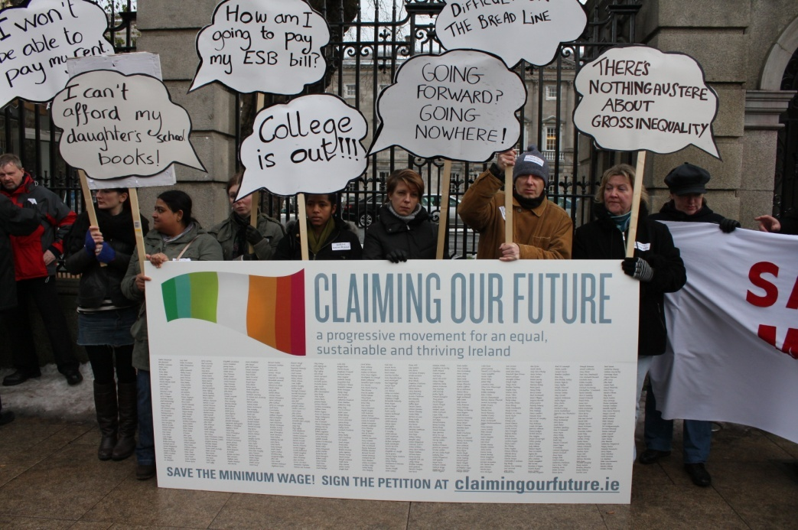

In 2011 MRCI produced/submitted the following:
- A briefing paper: A Framework for Tackling Forced Labour In Ireland
- Submission to the UN Universal Periodic Review which involves a review of the human rights records of all 192 UN Member States once every four years.
- Comments and Recommendations on the Reform of the State’s Employment Rights and Industrial Relations Structures and Procedures

- Submission to the Irish Government’s Consultation Process on Progress on the Implementation of the International Convention on Economic, Social and Cultural Rights

In the past year over 3,000 migrant workers have participated in advocacy and campaign actions. Over 30 meetings have been conducted throughout the country. Communications systems have been set up to support linkage and engagement of migrant workers in key MRCI campaigns.
Racism
Countering racism is a continuing priority for MRCI and considerable resources and support has been allocated to this work Ongoing support for ENAR Ireland was provided including financial, administrative and office space. As part of the INAR racist monitoring initiative we are continuing to operate an organisational racist monitoring system in MRCI.
During 2011 a report on ethnic profiling was published ‘Singled Out’ and received much public attention. This will continue to be an area of attention into the future.
Strategic Objective: To proactively provide migrant workers with the opportunities to develop leadership capacity
In the past year over 3,000 migrant workers have participated in advocacy and campaign actions. Over 30 meetings have been conducted throughout the country.
All the campaign core groups continued to regularly meet during 2011 i.e. Right to Change Employer, Criminalisation of Forced Labour, Diplomatic Immunity and Regularisation Campaigns training has been conducted with these groups (usually residential) and the participation of migrant workers prioritised in our advocacy and campaigning activities.
All campaigns i.e. Right to Change Employer, Diplomatic Immunity and Justice for the Undocumented Campaigns have established core groups in which migrant leaders participate. Intensive training has been conducted with these groups (usually residential) and the participation of migrant workers prioritised in our advocacy and campaigning activities.
Mpower
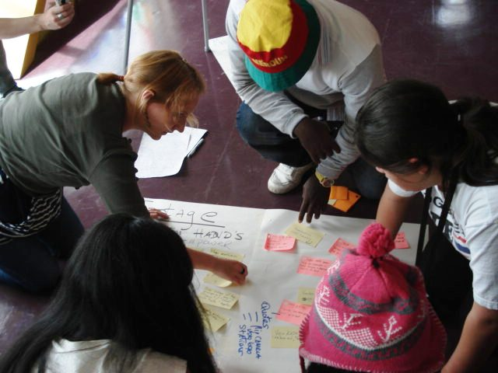
In 2011 we launched our Mpower youth empowerment project. This project aimed to promote the active engagement of third country national migrant young people in a creative youth empowerment programme and raise awareness of the issues experienced by them. The purpose was to facilitate a group of migrant young people in a developmental process to explore and document their experiences of living and studying in Ireland. Creative art and multimedia based methodologies were used to engage young migrants to explore and document their experiences. This creative process explored issues such as identity, inclusion and education that arise in young people’s lives. The culmination of this work was a 20 minute movie called “Making Ireland Home: Sharing the stories of young migrants” which was shown in a public screening on November 10th.
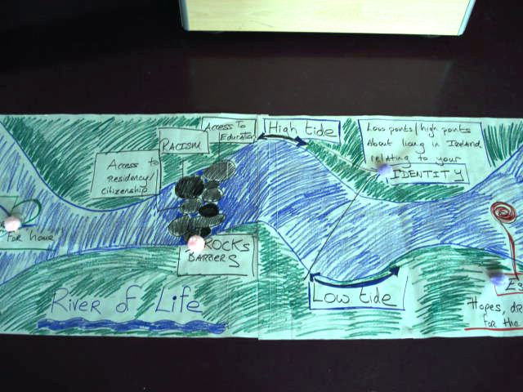
Migrants Forum
The Migrants Forum is held approximately every two months in the Teachers Club on Parnell Square. The Forum provides an opportunity for migrant workers to receive and share information, form a collective analysis of their experiences, and take action on issues affecting their lives. The Forum continues to be an important opportunity to foster self advocacy and to support the leadership potential of migrant workers. UN International Migrants Day was celebrated on December 19th and was a great success.
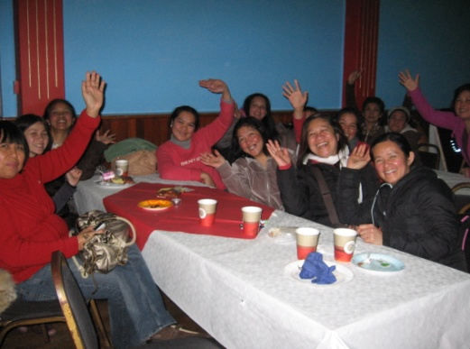
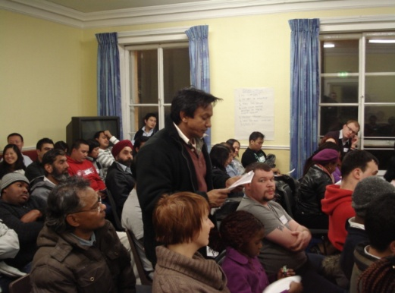

Migrants Forum February 2011 December 18th Celebration 2011

Domestic Workers Action Group
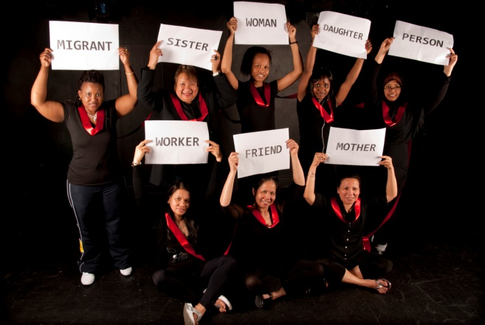
The Domestic Workers Action Group (DWAG) launched a play during Domestic Workers Acton Week in April 2011, ‘Acting Out For Hope and Change”. The production was the result of ten weeks of drama workshops between Rampant Productions and the women of DWAG. Using improvisation, drama and interviews, the performance examined the hopes and realities of the women, who all share one common experience of being migrant women living and working in the homes of their employers as childminders and caregivers. The Group performed the play in many venues/events including the Asylum Centre in Balseskin, North Dublin.
Another key event during the year was the annual Gala/AGM dinner held in November, which was a huge success. Membership grew in this period and a tremendous amount of work was put into building participation, advocacy training and developing decision making structures.
DWAG Gala dinner, November 2011
ILO Convention on Decent Work for Domestic Workers
On June 16 2011, the International Labour Organisation (ILO) committee adopted Convention no 189 on Decent Work for Domestic Workers. MRCI’s Domestic Workers Action Group has been campaigning both nationally and internationally for over two years to ensure that the proposed Convention would not only be adopted but also reflect the real needs of all domestic workers, regardless of their immigration status, or whether they are employed by a diplomat. The department of Jobs, Enterprise and Innovation (DJETI) said this would not be on the agenda until 2012, but also re-affirmed the government support for the ILO Convention in Geneva in June. MRCI will continue campaigning on ratification in 2012.
Restaurant Workers Action Group
During 2011 the Restaurant Workers Action Group (RWAG) has harnessed minimal resources to impact positively on wage levels and working conditions for migrant workers and all workers employed in the restaurant industry. Through the establishment of the Restaurant and Catering Workers Forum with SIPTU, RWAG has attempted to mainstream a campaigning and community work approach to working to improve conditions and protect wage levels with workers within the industry.
In March 2011, workers from the Restaurant and Catering Workers Forum presented the newly-elected TDs arriving for their first day in office with some breakfast snack. This ‘power breakfast’ came with a message to protect the minimum wages and conditions of restaurant and catering workers.

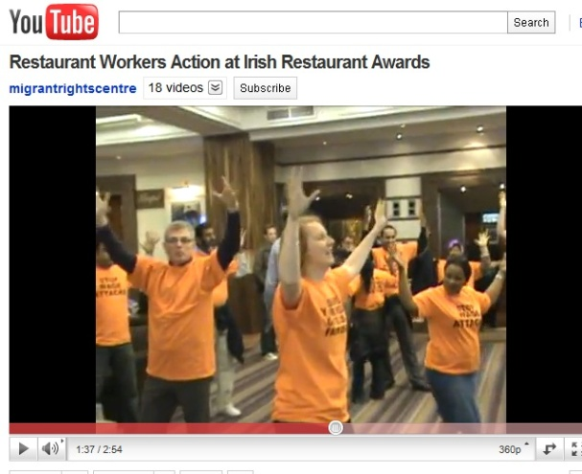
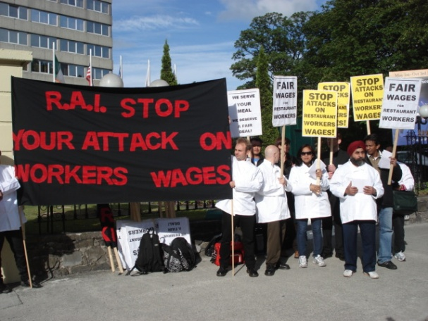
In April 2011, RWAG staged a flash mob at the Burlington hotel in Dublin where the Restaurant Association of Ireland were holding their annual awards. Objective of the action was to counter the Restaurant Association of Ireland’s public campaign to cut workers wages. This action was an opportunity for workers in a public and a creative way to deliver their message about the importance of protecting workers wages.

In December 2011, RWAG was invited to participate in a transnational restaurant workers convention in Toronto, Canada organised by the Restaurants Opportunities Centre United (ROC). Enamur Chowdhury a founder member of the RWAG and Helen Lowry RWAG coordinator travelled over for the event. The convention focused on gender discrimination in the restaurant industry as well as ROC's global justice campaign tackling exploitation and poor conditions in restaurants. RWAG presented their work highlighting the issues facing immigrants employed in restaurants in Ireland and work together globally to improve conditions and fight exploitation.
Leadership Development
A number of leadership development sessions were organised between MRCI and SIPTU aimed at activists and leaders from an immigrant background. This work was supported by the Dept of Applied Social Studies, NUI Maynooth. Twenty four leaders participated.
In October a residential training programme ‘Opening Doors’ was held in Maynooth focusing on issues of power and privilege. It brought together leaders and workers from across a variety of settings who are involved in social justice work.
Communications
MRCI continued to maintain and strengthen its political profile during 2011. The various campaigns we were involved in provided opportunities for extensive coverage i.e. Primetime, national and local news – print and broadcast. Media coverage in 2011 continued to be high, with regular press coverage of MRCI campaigns. There were 57 articles in national press including two articles in the Irish Times one on forced labour and the other on a regularisation programme for undocumented migrants. Also included is an article in the Irish Examiner on the exploitation of Domestic Workers in Ireland. Radio coverage (29 hits) including Today FM – Last Word where the issue of Forced Labour in Ireland is discussed and two features on the Pat Kenny show (forced labour and Domestic workers exploitation). Television coverage (5 hits) included TV3 Vincent Browne and a discussion with Siobhan on low wage worker.
Organisational Development
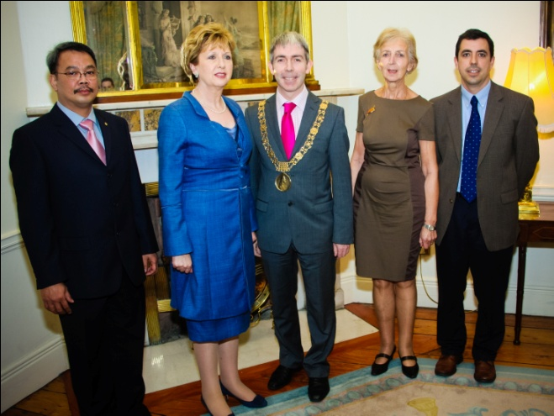
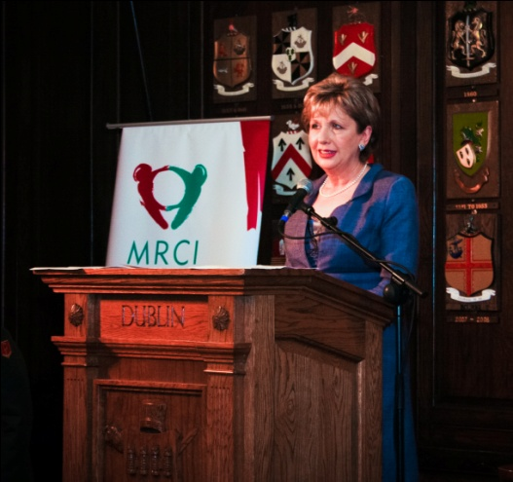
2011 was the ten year anniversary of MRCI. In October we held a celebratory event in the Mansion house with a key note speech from the outgoing president Mary McAleese. On the night MRCI showed a short film on the work of MRCI.

During 2011 we conducted a ‘Review & Options’ process with an external evaluator. This review process assisted with the identification of strategic choices and decision making for MRCI’s short to medium term future. The strategic plan for the period 2012 – 2015 was developed on foot of this initial process.
As a result of significant funding cuts a number of staff positions were made redundant. These included Bill Abom (Deputy Director), Delphine O’Keeffe (Communications Officer), Pat O’Donoghue (Legal Advocacy Worker), Raluca Anucuta (Policy Support Worker) and Laura Gerulyté (Receptionist).
Organisationally significant planning was conducted to maintain maximum team cohesion and ensure best use of resources towards our stated goals.
Special thanks is offered to the interns, volunteers and students from NUI Maynooth who contributed so much to the work of MRCI during 2011 including Clare McCrum, Emer Morrissey, Christine O’Donnell, Emily Hosford, Justin Killeen, David Traynor, Claire Martinez, Ian McGahon, Miranda Ruddock, Patricia McDwyer, Brendan Cummins, Daniel Kearney, Dubhaltach Mulvenna, Sarah Maguire, Lisa Fergus and Razieh Nikoomanesh.

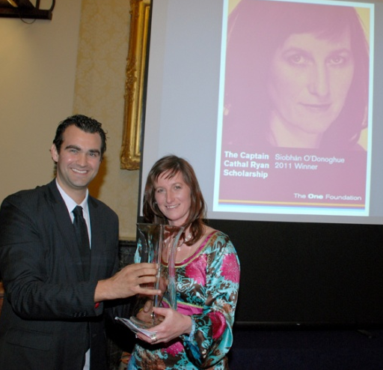
MRCI Team 2011
The Captain Cathal Ryan Scholarship Award
Siobhán O’Donoghue received the prestigious Captain Cathal Ryan Scholarship Award at an official ceremony hosted by The One Foundation in Dublin in October 2011, in recognition of her work to promote equality and social justice in Ireland.
Funding
The funding environment proved challenging in the context of the deepening economic crisis. Our Core funding from the Department of Community Rural and Gaeltacht Affairs was discontinued. We continue to receive support from the Columban Missionary Society. The ONE Foundation agreed to continue support until the end of 2013.
MRCI commenced a progamme of training and skill development in relation to fundraising with the support of ONE Foundation and the ‘For Impact’ programme.

Governance
MRCI’s Board met 5 times during 2011. The Finance Subgroup met 4 times and the Staff and Employment Subgroup met 2 times. The annual joint team/Board meeting took place in December where the work programme and budget for 2012 was presented, discussed and agreed. There were three resignations from the board in 2011; Tatiana Kovalenko, Rajat Bhatnagar, Alan Grossman. New appointments were Hilda Regaspi as Chairperson, Bobby Gilmore as President.
Risk Analysis
Meeting the funding needs of the organisation presents the biggest risk to the work of MRCI. At the end of 2011 ONE Foundation agreed to continue funding until 2013, Atlantic Philanthropies will not make a decision until 2013. As part of the strategic planning process a detailed sustainability plan was developed reflecting the gaps and needs of the organisation into the future.
The risk of losing key staff while continuing to operate in a high demand environment presents a number of risks. A restructuring process has been undertaken and a reprioritisation of work priorities agreed. A transition phase will be implemented for Q1 for 2012 to accommodate a period of transition and adaptation.

