Migrant Rights Centre Ireland Annual Report
2008
Foreword

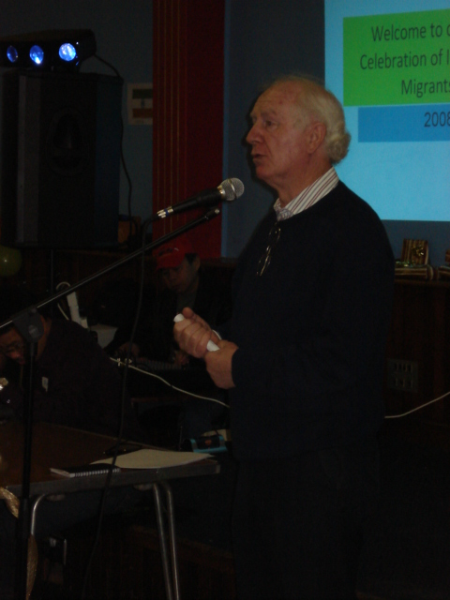

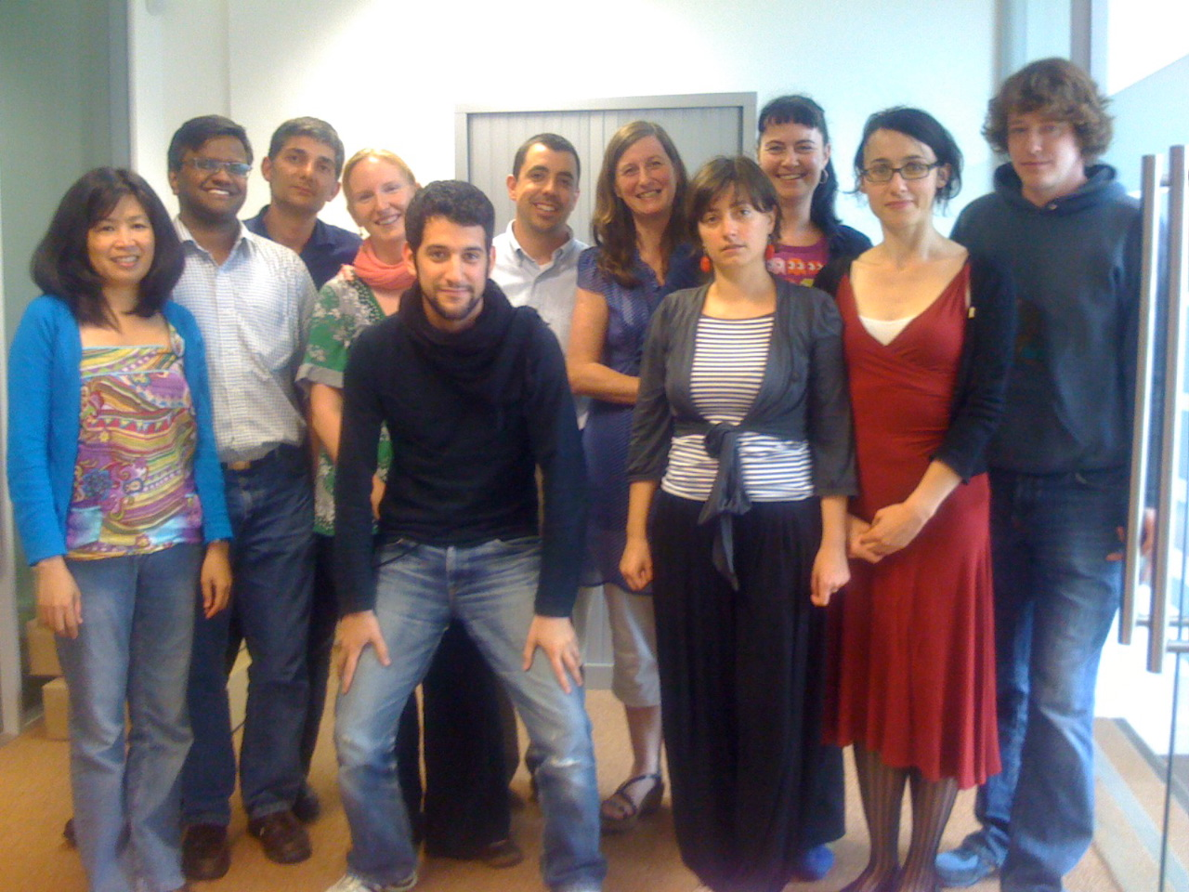

At the end of 2008 Ireland was in the grip of the worst recession since the Second World War. Migrant workers appeared to be loosing jobs faster than most and MRCI saw a definite increase in people reporting difficulties in securing their redundancy rights and event the most basic of employment rights. Concerns about the increase in racism and hostility towards migrant communities began to materialise in reported incidents to the MRCI and to others. Thankfully the public discourse has so far apart from some notable exceptions steered clear of blaming migrants for the situation we find ourselves in. Unfortunately this is not the case in other countries and we are bracing ourselves for the inevitable backlash over the next while. Parallel to this we have seen the equality and anti racism infrastructure effectively silenced and eroded within a matter of months at the end of 2008.
This is the context MRCI finds itself in at the end of 2008 and without doubt has challenged us to both hold the ship steady and refocus our efforts in the most strategic way feasible in this very hostile environment. The organisation is keen to stand in solidarity with our colleagues in the community and voluntary sector who are also battling to have the voice of those most vulnerable heard and protected at this time. We will double our efforts to ensure that the old ‘divide and conquer’ mentality does not override and to this end are committing ourselves to tackle racism in all its forms primarily through supporting stronger networking and collective action amongst anti racism groups and organisations. Solidarity will be the theme for 2009 – solidarity with the trade union movement, solidarity with the community and voluntary sector, solidarity on an all island basis with our colleagues in the North of Ireland, solidarity at an EU and international level and most importantly solidarity with migrant workers. While there is much to feel concerned with at the end of the year it is also true that there are opportunities to be grasped. While true too that very little can be gained whilst in ‘defence mode’ it is MRCI’s intention to keep up the good fight in the interests of rights for migrant workers and equality for all.
Finally we want to acknowledge the hard work of all the people associated with the MRCI. MRCI is a broad family of paid staff, unpaid staff, volunteers, participants and colloboratives. It is through our collective effort that we are in such a strong position to advance our mission and achieve our identified priorities.

Siobhan O’ Donoghue
Bobby Gilmore
Strategic Plan 2008/2011

During 2008 MRCI completed a new strategic planning process. Our new plan runs until the end of 2011. Given the identified need to refocus our work and priorities the second half of 2008 was identified as a transition and restructuring phase. During this period there was an emphasis on management structures, creation of project teams, adapting systems and procedures, communications and information provision. Four new project teams were created – referral and mainstreaming, workplace rights, integration and leadership, trafficking and irregular migration.
Arising from the strategic planning process three strategic priorities were agreed for the period 2008/11.
A. To strengthen the rights and protections for migrant workers who are at risk of or experiencing workplace exploitation, are trafficked for forced labour or are undocumented
B. To mainstream a focus on migrant workers at risk of social exclusion, poverty and discrimination within service and information provision and within community and local development
C. To proactively provide migrant workers with the opportunities to develop leadership capacity
This annual report is structured around these strategic priorities.

Overview of case work with migrant workers in 2008
In total, we had 5,422 inquiries in 2008. Out of this overall figure 2,008 were new inquires. Migrants new to MRCI were primarily recommended by members of their own communities. Overall, word of mouth referrals account for 77 % of all of new migrants coming to MRCI. This would seem to indicate that MRCI has become well established in the migrant population and that past users of MRCI’s services are providing positive referrals back into their communities.
Migrants to Ireland come from all over the world. As with 2007 and 2006, migrants in 2008 came from over 100 different countries with the largest number coming from the Philippines (14 %). This was followed by Lithuania Ukraine, China. In contrast in 2007, India and Lithuania were the biggest sending countries after the Philippines.

[Type sidebar content. A sidebar is a standalone supplement to the main document. It is often aligned on the left or right of the page, or located at the top or bottom. Use the Text Box Tools tab to change the formatting of the sidebar text box.
Type sidebar content. A sidebar is a standalone supplement to the main document. It is often aligned on the left or right of the page, or located at the top or bottom. Use the Text Box Tools tab to change the formatting of the sidebar text box.]

In 2008, there continues to be a greater number of male versus female migrants contacting MRCI. There were 57 percent male migrants. There are some large discrepancies in the male to female ratio in geographies of origin. Almost 90 % with recorded ages are between 20 and 49, with the majority between 30 and 39.
Of the 1,089 reporting current employment, 24 %work in the restaurant sector. An additional 12 %work in agriculture and in services/retail/security and 11 % in construction.
Approximately 42 % of all migrants upon contacting MRCI have legal permission to work; this includes those with work permits, EU citizens and unlimited work permits. It does appear that the number of individuals contacting MRCI as undocumented has slightly increased over time.
22% of migrants reporting being currently employed reported experiencing workplace exploitation. Agricultural sector, employment in the home, and restaurant sectors are the most reported sectors.
There are four main types of exploitation experienced by migrant workers; working without a contract, working over time with no pay, being paid below minimum wage, and unfair dismissal.
A very small number of individuals report being trafficked for forced labour in 2008. There were eight , four working in a private home, one working in a restaurant, and three working in an unreported sector.
In 2008, there were 432 migrant workers with an undocumented legal status representing an increase on previous years.

Strategic Priority 1. To strengthen the rights and protections for migrant workers who are at risk of or experiencing workplace exploitation, are trafficked for forced labour or are undocumented

Rights of Undocumented workers
In January 2008 Minister Brien Linehan in a meeting with the MRCI committed to introducing a scheme giving formal effect to the practice of issuing temporary residency permissions to migrant workers who had become undocumented through no fault of their own. He also announced his intention to do this in the Dail. This announcement suggested a successful conclusion from the campaign MRCI had been running for the previous number of months. However by December 2008 no statutory scheme or policy statement had been made. In a further meeting with Department officials MRCI was informed that the approach now favoured was a once off regularisation scheme. A new campaign is now planned to ensure that a regularisation scheme captures as a wide a group of undocumented workers as possible while also including provision for the ongoing bridging visa mechanism. In an analysis of the ‘de facto’ bridging visa cases processed by the DJELR during the year a near 100% successful outcome was secured in over 200 cases.

Workplace Exploitation
Overall the area of workplace exploitation dominated much of our case and policy work during 2008. MRCI met with Kieran Mulvey the head of the Labour Rights Commission to discuss the recommendations from our report ‘Access to Legal Redress’. An analysis of cases taken highlighted that migrant workers received settlements and awards of €1,028,000 for back wages and other gross violations of their employment rights in complaints brought with the help of the Migrant Rights Centre Ireland (MRCI), over a two-year period.

A number of meetings were held with NERA (National Employment Rights Authority) who agreed to work more closely and strategically with MRCI on specific cases and areas of mutual concern. At a meeting in MRCI’s offices Minister of State Billy Kelleher emphasised the need for greater cooperation in the pursuit of employment compliance and rights.
Trade Unions developed worked hard to progress the Employment Rights Compliance Bill which was published during 2008. MRCI developed a submission and met with ICTU and SIPTU to advance our own priorities in this area. In particular MRCI used the opportunity of the Primetime debate following the primetime documentary on workplace exploitation to publicise our recommendations on the Employment Rights Compliance Bill
One of the highlights for MRCI in 2008 was our participation in RTE’s Primetime Documentary on exploitation of migrant workers. It provoked a tremendous public reaction, had a direct impact on many migrants working conditions and exposed in a very effective way the true power dynamics at play in the workplace. MRCI received a lot of positive reaction including a statement that the Oireachtas Committee on Employment and Small Businesses that the issue of exploitation of migrant workers will be placed on their work programme for 2009.

Forced Labour including Trafficking

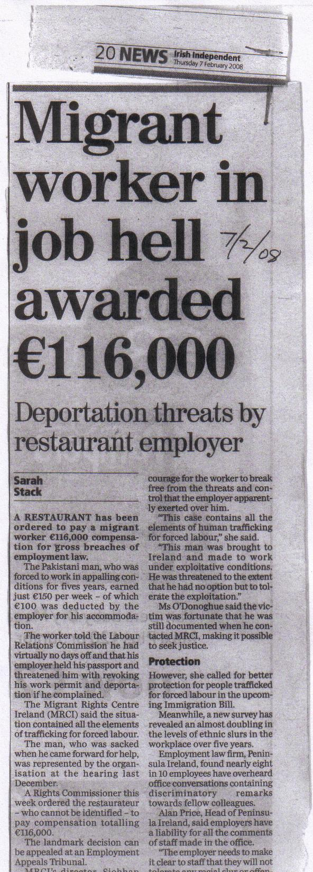
During 2008 the Trafficking in Persons Act was finally enacted and the Irish Human Trafficking Unit established. MRCI played an active role advocating for the establishment of a national referral mechanism for the victims of trafficking and ensuring that forced labour was given sufficient attention by the IHTU. MRCI also participated in a number of training sessions on trafficking organised by IOM for Gardie, Social Welfare officers and others.
A highlight for MRCI was the judgment made in a case of a migrant worker who we had identified as a victim of trafficking for forced labour. The judgement awarded a high sum of money but more significantly the judgement identified the various elements of forced labour. Given the limitations of anti trafficking legislation the route of employment rights is now viewed as a significant avenue to securing justice and rights. During 2008 we received many requests to present and share our approach and practice in the area of forced labour inc trafficking i.e. OSCE, CCME

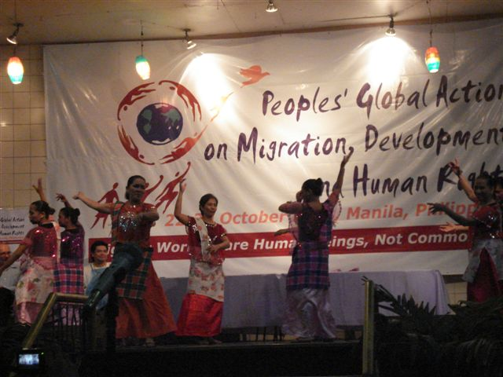

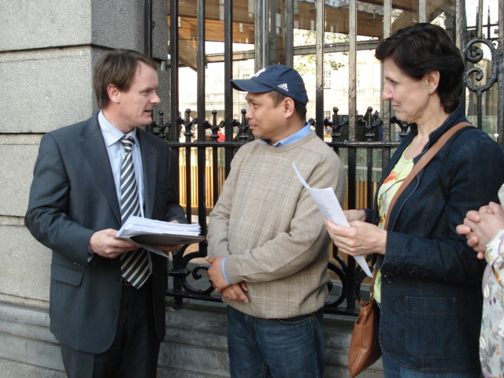

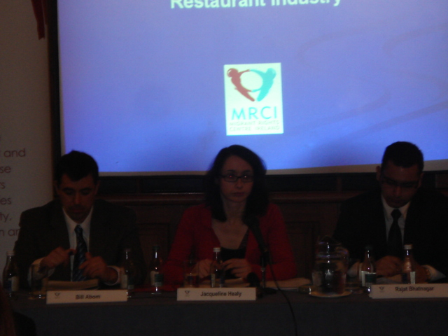
To assist in developing our analysis we organised a seminar with Bridget Anderson from Oxford who has researched and written extensively on the theme of trafficking and forced labour. This seminar was part of a series of reflection seminars organised with ICI on the theme of trafficking. A second one was led by Liz Kelly an expert in the area of trafficking for sexual exploitation.

Immigration policy
The Immigration Residency and Protection Bill was debated and proceeded through the various stages of the Dail during 2009. MRCI continued to advocate on its submission with the emphasis on rights of undocumented workers. Throughout the year a number of meetings were conducted with the Garda National Immigration Bureau on procedures and practice relating to enforcement of immigration policy.

Strategic Priority 2. To mainstream a focus on migrant workers at risk of social exclusion, poverty and discrimination within service and information provision and within community and local development

Equality and anti Racism
2008 was a difficult year for the advancement of equality, anti racism and for local and community development. The budget in October saw detrimental cuts to the budget of the Equality Authority and the cessation of funding to NCCRI who subsequently closed in December 2008. The ‘Cohesion process’ saw the amalgamation of area based partnerships with leader companies and a general dilution of the anti poverty, equality and social inclusion emphasis promoted through the local development board process.
As the coordinating organisation in ENAR Ireland (European Network Against Racism) MRCI stepped up its efforts to support the networking and collective efforts of ENAR Ireland. Likewise MRCI continued to play an active role in the Community Platform and in particular supported the publication of the Platforms publication ‘A Better Ireland is Possible’ Through the Community Workers Cooperative we actively supported in the development of ‘All Ireland Standards for Community Work ‘. Work continued during 2008 on the development of a toolkit for community work with migrant workers. One practice seminar on communications and advocating for migrant workers rights was organised for community workers.

Referrals and mainstreaming
A central challenge identified in MRCI’s strategic plan is to increase the number and quality of referrals made to organisations that have responsibility with delivering services and information to all members of society including migrant workers and their families. To give effect to this commitment a number of structural changes were made during the restructuring phase July/Dec 08. A referral system was designed and made operational in the Drop In Centre. All callers/visitors to the DIC are initially screened and if the query is a) not an area MRCI is prioritising or b) directly in the remit of an other organisation the person is referred to the appropriate person/organisation. If it is a query of relevance to MRCI the person is referred internally to one of the project teams or Action Groups. The referral system also incorporates follow up on external referrals and capturing relevant data on referrals made etc. There has been an increased emphasis on information provision with an Information Worker recruited in Oct ’08 with the remit of supporting information provision to referral organisations and mainstream organisations to enhance their capacity in responding to the needs of migrant workers and their families.

Case Management System
The Case Management System has been redesigned to capture the priorities of MRCI as set out in our current strategic plan. A system of recording incidents of discrimination and racism has also been put in place.

Strategic Priority 3. To proactively provide migrant workers with the opportunities to develop leadership capacity

Leadership Development Programme
Over the 2008 a leadership programme with 16 migrant workers ran. The course involved approx 60 hours of training and learning. Topics covered included analysis of migration, group work, social analysis, community work, antiracism and non discrimination, media and communication skills. Participants were drawn from the various action groups and the migrant forum where they were actively encouraged to operationalise the skills, knowledge and analysis developed.
[Type sidebar content. A sidebar is a standalone supplement to the main document. It is often aligned on the left or right of the page, or located at the top or bottom. Use the Text Box Tools tab to change the formatting of the sidebar text box.
Type sidebar content. A sidebar is a standalone supplement to the main document. It is often aligned on the left or right of the page, or located at the top or bottom. Use the Text Box Tools tab to change the formatting of the sidebar text box.]

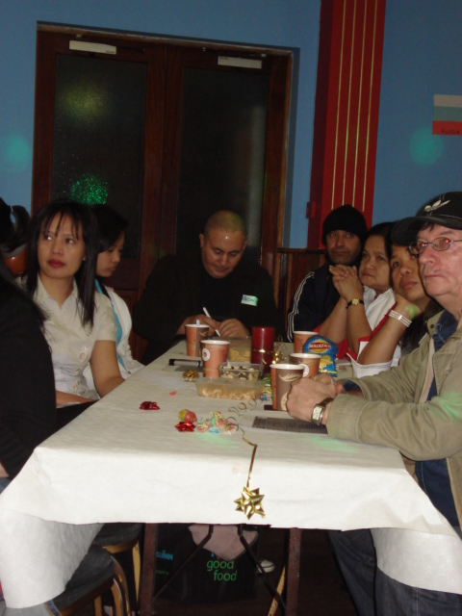

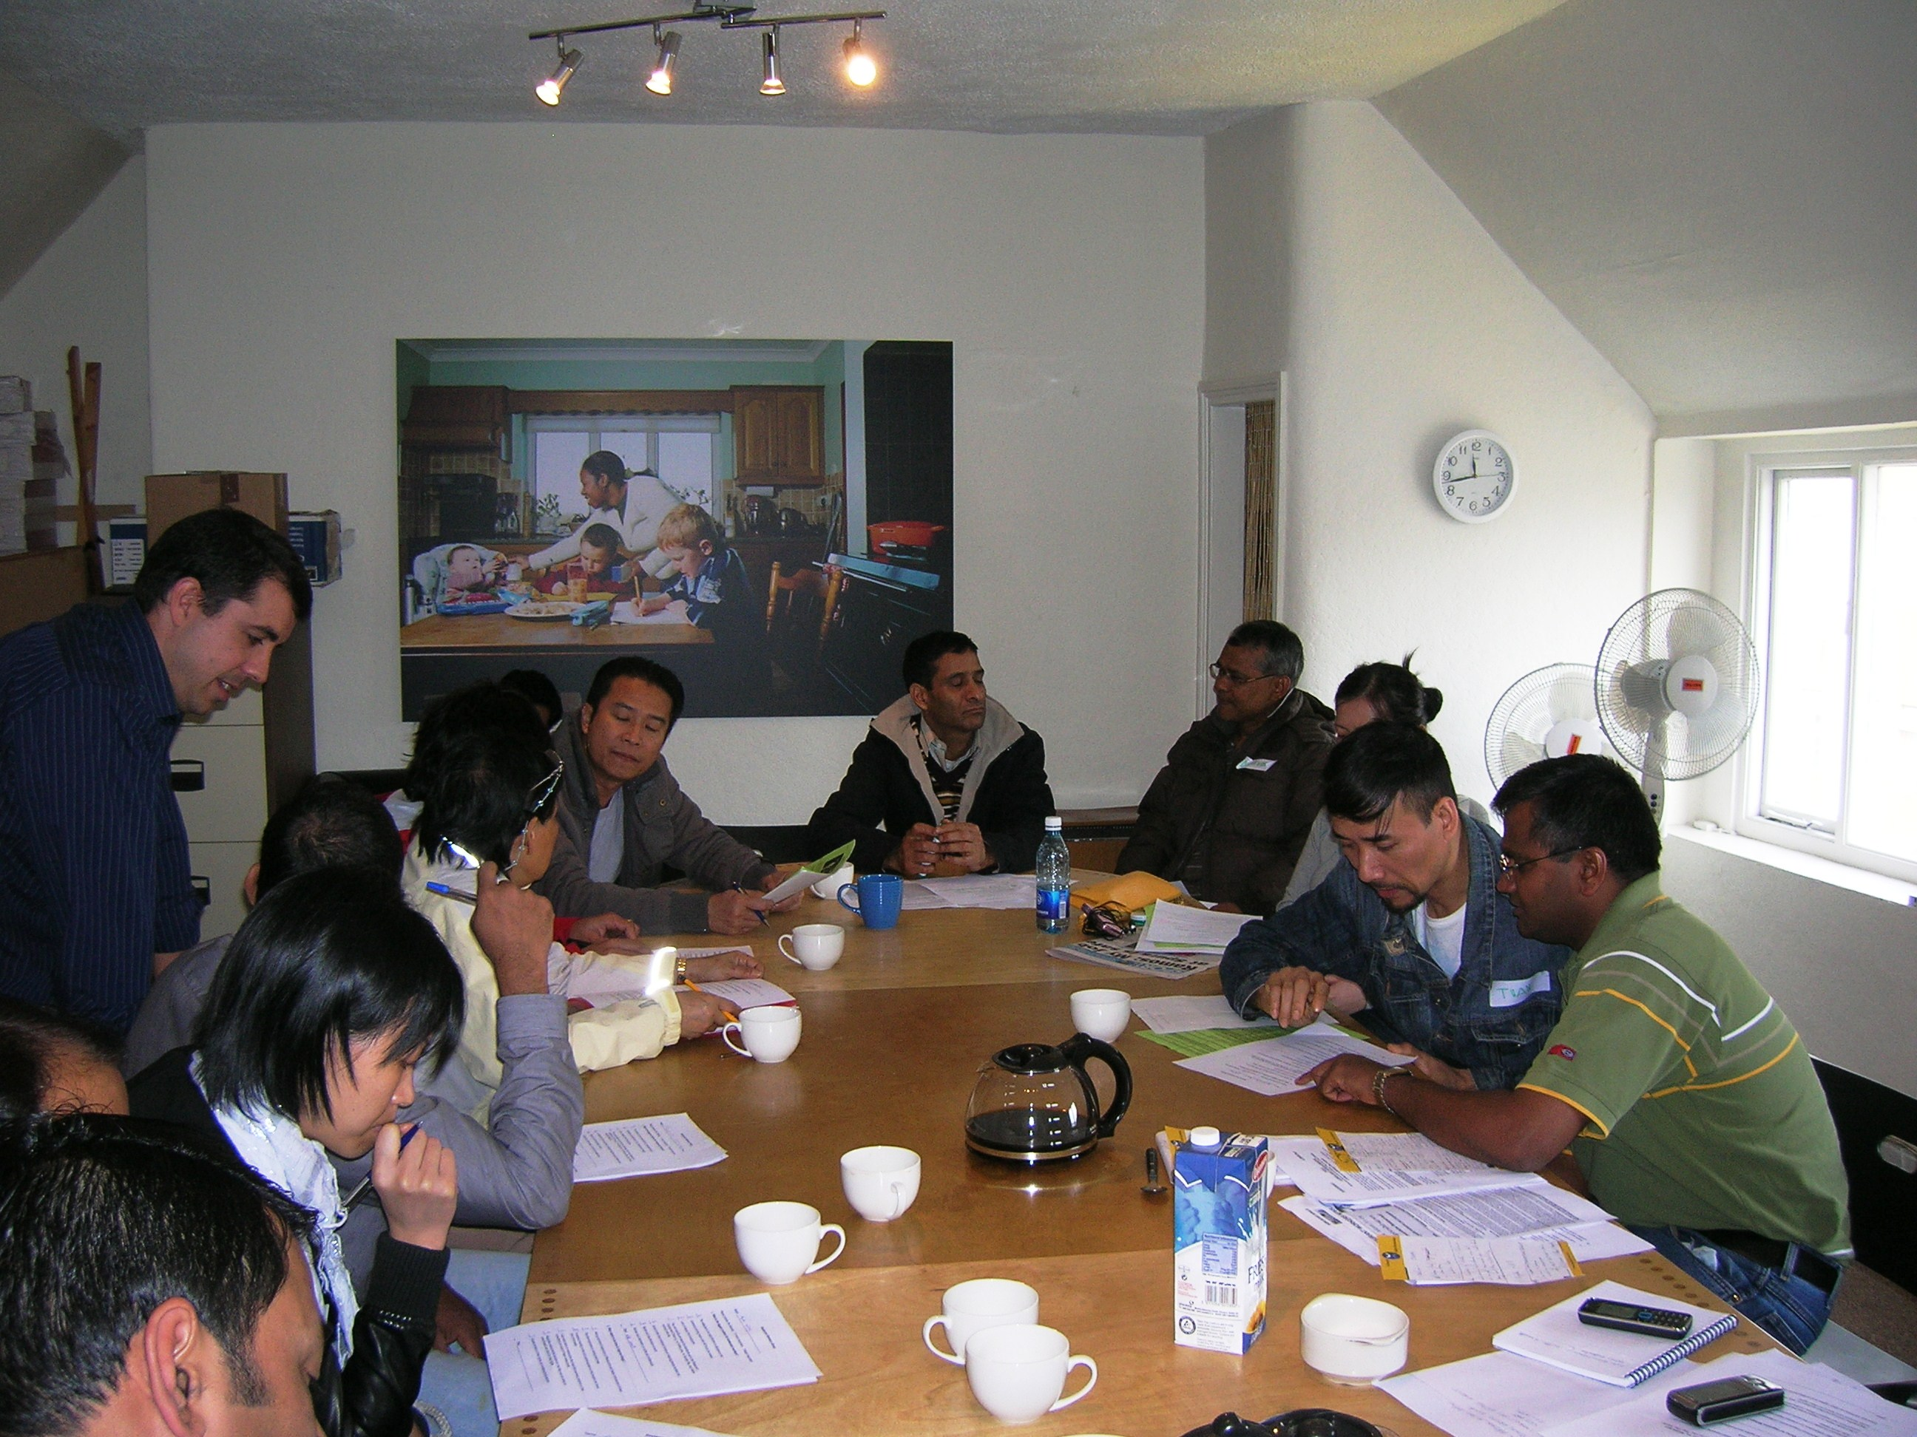

Restaurant Workers Action Group
In response to growing contact with migrant workers employed in the hospitality and restaurant industry and the high levels of exclusion, isolation and exploitation being reported it was agreed to commence community work actions with people we were coming in contact with. Through this process the Restaurant Workers Actions Group was established and continued to grow in strength and numbers during 2008. The highlight was the launch of the report ‘Exploitation in the Restaurant Sector’ in Dec 2008. The active participation of migrant restaurant workers was notable and served to ensure that the recommendations contained in the report were actively supported in particular by the trade union movement. During the year two newsletters targeting migrant restaurant workers were produced and widely circulated.

AgWa (Agricultural Workers Association)
This year unfortunately due to lack of funding we lost a key worker supporting agriculture workers, Sintije Sheeran. Despite this the group continued to meet and the concerns of agriculture workers continue to be represented for example on the Agriculture JLC (Joint Labour Committee) with the support of SIPTU.

Domestic Workers Support Group

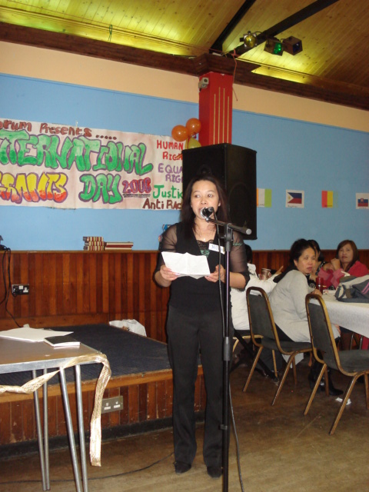

The DWSG continued to meet monthly during the year with the core group meeting more regularly to organise the group and develop its plans. Members of the group participated in the leadership programme and had many opportunities to put their skills into action. Over the year there was an increase in requests to present and speak on issues facing domestic workers in Ireland. The work of the group was also presented at the UN Migration Forum held in Manila. The photographic and quilt exhibition produced by the group was also exhibited a number of times during the year. In December 08 news of successful funding to support the employment of a coordinator for the group was received.

Migrants Forum
The Migrants Forum met 5 times in 2008. Participation in the Forum continued to reflect the wider migrant worker constituency MRCI engaged with i.e. high participation from Asia and other non EU regions. One of the highlights for the Forum during 08 was the annual Celebration of International Migrants Day (Dec 18). This year the emphasis was on showcasing the work of the various MRCI action groups. Other thematic areas covered by the Forum during 2008 included voter registration and the situation of work permit holders. At one forum Migrant workers presented their experiences and concerns relating to the system to officials from the Department of Enterprise Trade and Employment. A DVD of the Forum was produced and has been used as a tool to communicate the work of the forum.

Kubbath Miah Fund

Kubbat, originally from Bangladesh, lived and worked in Ireland as a chef for ten years, from 1998 – 2008. He died in June 2008 having suffered needlessly and having tremendous hardship caused from having been exploited and subsequently becoming undocumented through no fault of his own. MRCI supported him throughout the process right up to the time of his death. He left behind him a wife and three young children in Bangladesh. Given the extremely tragic circumstances of his case, the level of injustice evident and the concern of several of his friends for Kubbaths family back home a fundraising effort was initiated. Fundraising through the MRCI raised over €3,000 which was sent to support his family back home.

Information and Communication
In MRCI’s strategic plan there is a renewed emphasis on quality and targeted communications and targeted information provision. Information provision is a key part of an effective referrals and mainstreaming strategy. During 2008 our website continued to be a source of information primarily for community and voluntary sector organisations. The e bulletin was produced 4 times and distributed to over 2,000 organisations. One edition of Migrant Ireland was published. 14 press releases were prepared and throughout the year MRCI continued to receive requests for statements, interviews etc. Training undertaken on lobbying and advocacy highlighted the need for a greater emphasis on communicating with the political system. An important emphasis of MRCI’s communications towards the end of 2008 was to highlight the significant contributions migrant workers make to the Irish society and economy. Using our own research and analysis we calculated that migrants contribute over €4 billion per annum. This analysis has been quoted and used in a range of arenas and fora.
Through our participation in FOMAC’s (Forum on Migration and Communications) MRCI team members participated in a number of training events designed to strengthen our campaigning and advocacy skills. A number of these were conducted with Frank Sharry a US expert on immigration reform.

Organisational Development
The key emphasis during 2008 was developing the new strategic plan which occurred over a 4 month period. A number of key organisational changes were then agreed and implemented during the restructuring phase (July/Dec). These included
- The creation of a coordinating team
- The redesign of new roles and recruitment of new staff
- The creation of new project teams – workplace rights, referral and
mainstreaming, irregular migration, integration and leadership

- Development of work plans – project team level and organisational

- Redefining the role of sub/working groups
There were a number of significant staffing changes during 2008. Orla O’ Flanagan our Administrator resigned and it was not until December 08 that a suitable replacement was identified. Jacqueline Healy our Deputy Director was approved for a one year leave of absence and departed in December.
A number of team planning and development sessions were conducted over the restructuring phase.

The evaluation framework operational in tandem with the strategic plan was concluded. Ide O’ Carroll our external evaluator facilitated the Board and team in a day long reflection session on the final evaluation report produced for MRCI. Ide has been reappointed as external evaluator for the duration of the new strategic plan.
MRCI’s performance management system, Strategy Map/Balanced Score Card 2005/08 was also successfully concluded and redesigned in the context of the new strategic plan.
MRCI’s Board met 8 times during 2008 including meetings to develop the new strategic plan.
The Staffing and Employment Subgroup, Finance and Staffing Subgroup, Policy Advisory Group, Data Tracking Group continued with their work with some refocusing in light of the new Strategic Plan

Funding
2008 was a significant year for MRCI in relation to funding. Core funding from the ONE Foundation and Atlantic Philanthropies both came to an end in July 08. MRCI was successful in securing a further core grant from the ONE Foundation. Atlantic Philanthropies were not in a position to decide on a new proposal until March 2009. MRCI’s strategic plan has been budgeted at €1.3million per year. At the end of 2008 approx 70% had been identified (including AP). A significant amount of time was also spent on developing a proposal under PEACE 3 funds involving a number of partners (Pobal, MRCI, STEP, CWC).

Risk Analysis
2008 was a transition year for MRCI. Completing one plan and developing a new one, completing two core funding contracts and completing all employment contracts presented a considerable risk scenario for the organisation. A key security for MRCI during this time was the availability of resources from our operational reserve established for such a situation. Regranting from ONE Foundation occurred relatively quickly which placed the organisation on a more secure footing. Any new staff position was offered a limited contract in light of the precarious funding situation and the lease on our premises has not been renewed until a clearer outlook is secured. MRCI has not been exposed in the same extreme way as most other organisations in the community and voluntary sector to the severe recession taking hold of Ireland at the end of 2008. While impacted by the external environment our core funding has not come from state funds but private funds. While there are clear risks with this scenario i.e. both foundations are ‘sunset’ foundations in the short term MRCI is in a more secure position than many.

MRCI Team at end of 2008
Siobhan O’ Donoghue – Director
Jacqueline Healy – Deputy Director On leave of absence Jan 09
Bill Abom – Projects Director and Workplace Rights Project Leader
Helen Lowry – Integration and Leadership Project Leader
Sancha Magat – Referral and Mainstreaming Project Leader
Edel McGinley – Irregular Migration and Forced Labour Project Leader)
Hilary Royston – Administrator (appointed Dec 08)
Delphine O’ Keefe – Communications Officer
Raluca Anucuta – Policy Support Worker
Heena Hassan – Information Worker (appointed Oct 08)
Virjinija Petrauskaite,– Workplace Rights Project Worker
Pat O’ Donoghue – Advoacy Worker (part time)
Laura Gerulyte Receptionist (appointed Oct 08)
Michael Higgins – Legal Advoacy Intern
Marianna Prontera - Irregular migration/forced labour intern
Kathryn Keating - Referral and mainstreaming intern

Other people who worked with MRCI during 2008 either on a paid or unpaid capacity include Orla O’ Flanagan, Nico Karadajan, Mary Woolhead, Lot Gernan, Ivy Byrne, Soraya Picado, Kasimir, Sintija Sheeran, Dorothee , Pablo Rojas Coppari, Nick Leonard, Giovanna Teijido Vasquez, Dorothee Meyer Holtkamp

